Math Mock 1 (in English) Difficulty level: 75

CSCA Mathematics – Mock Exam (48 Questions, 60 minutes)
Instructions
- Choose the best answer for each question (A–D).
- Work quickly; calculations are simple and mostly plug-in or one-step.

A. Sets & Inequalities

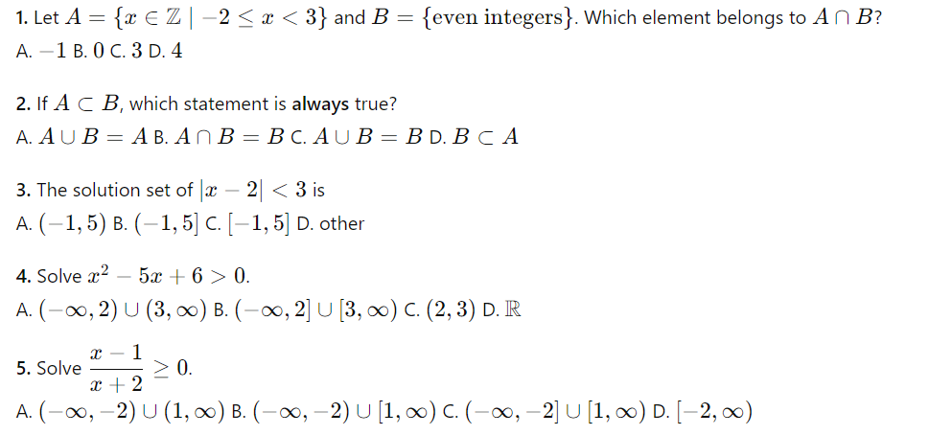
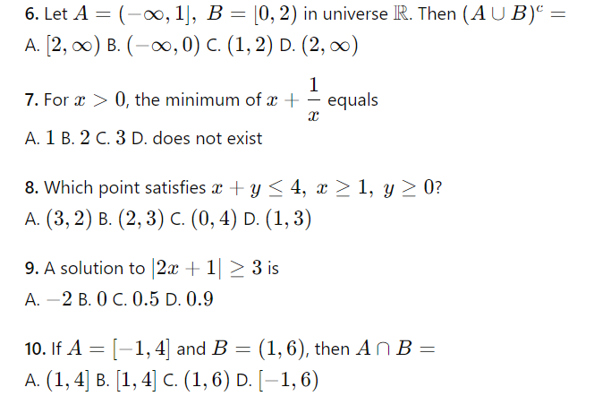

B. Functions
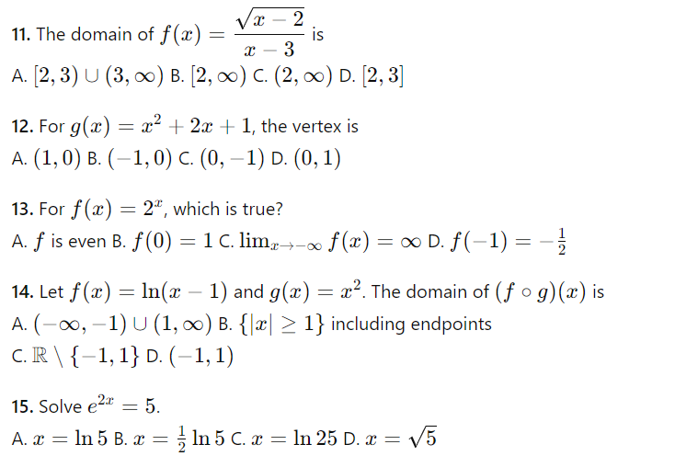
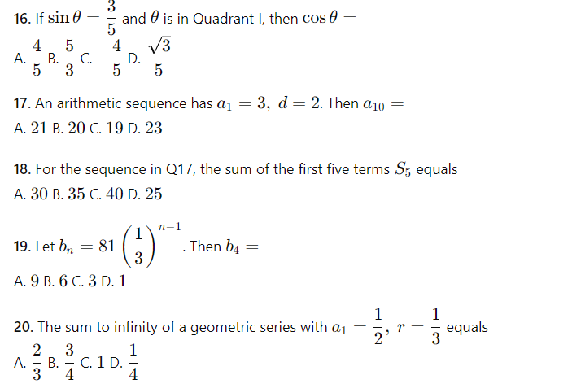
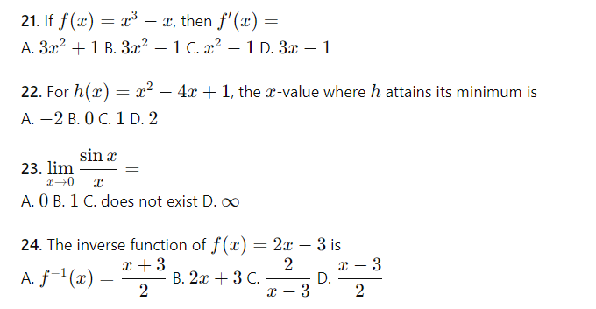

C. Geometry & Algebra
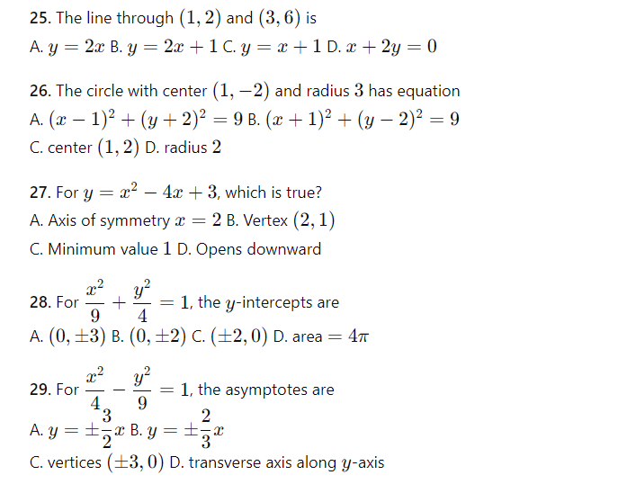
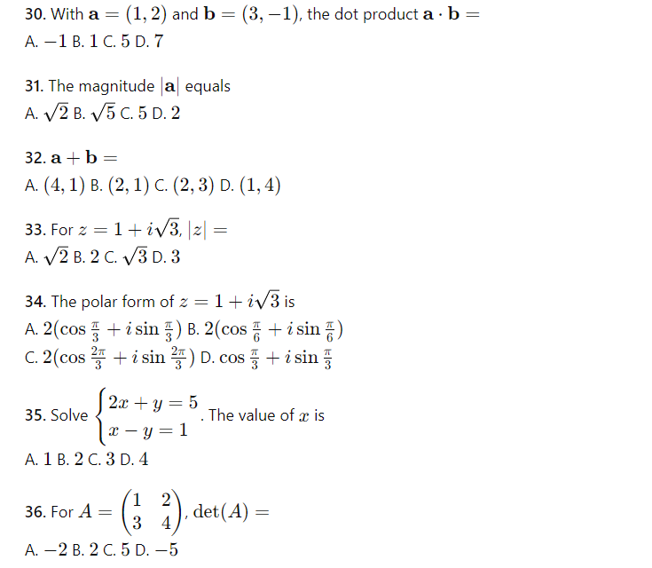
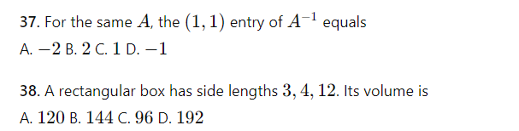

D. Probability & Statistics

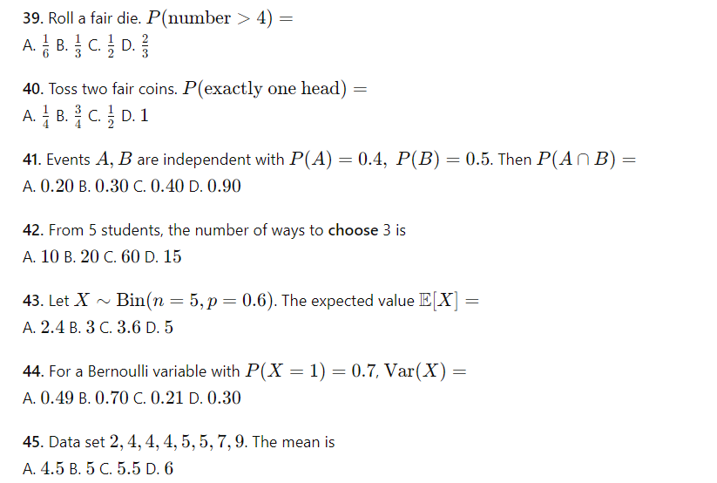
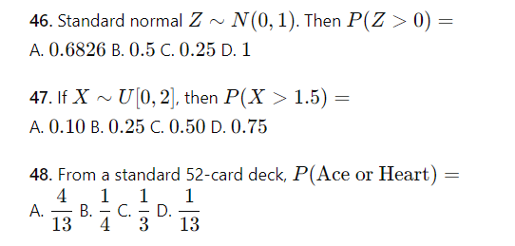

Answer Key
1 B 2 C 3 A 4 A 5 B 6 A 7 B 8 D 9 A 10 A
11 A 12 B 13 B 14 A 15 B 16 A 17 A 18 B 19 C 20 B
21 B 22 D 23 B 24 A 25 A 26 A 27 A 28 B 29 A 30 B
31 B 32 A 33 B 34 A 35 B 36 A 37 A 38 B 39 B 40 C
41 A 42 A 43 B 44 C 45 B 46 B 47 B 48 A

Math Mock 2 (in English) Difficulty level: 65
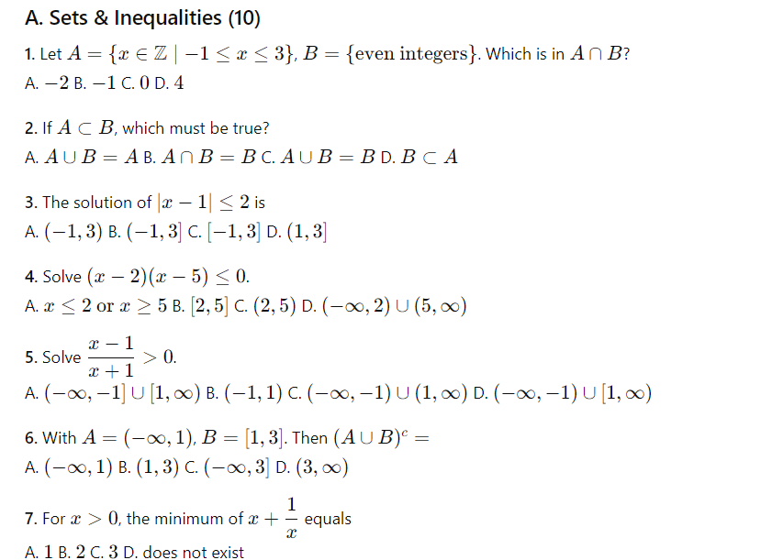
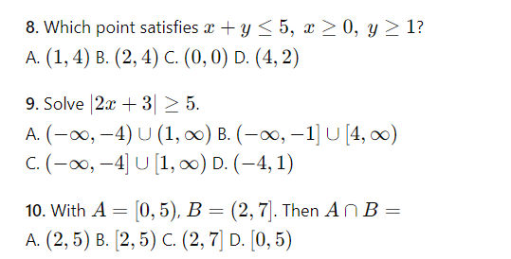
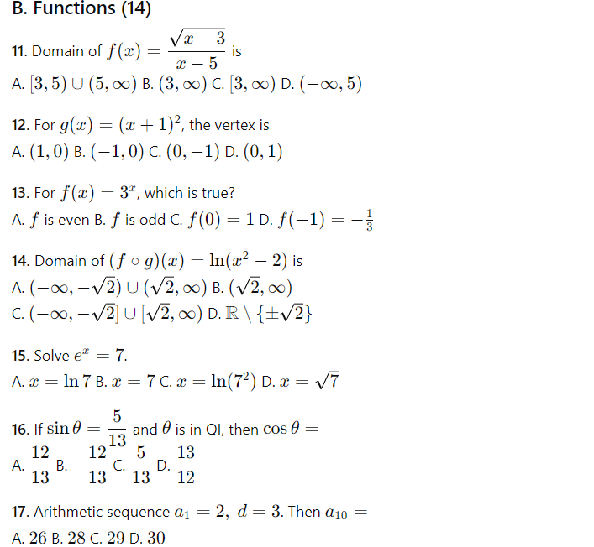
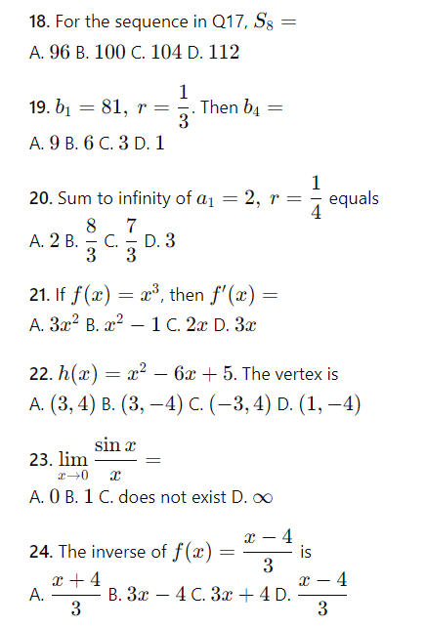
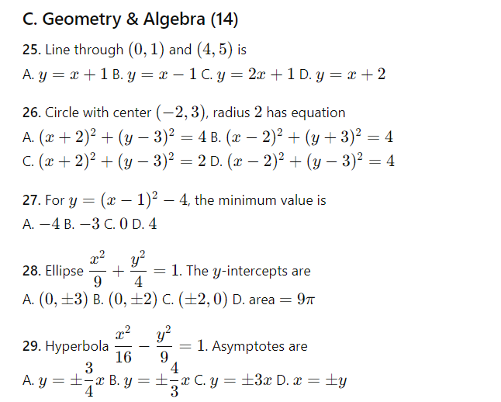
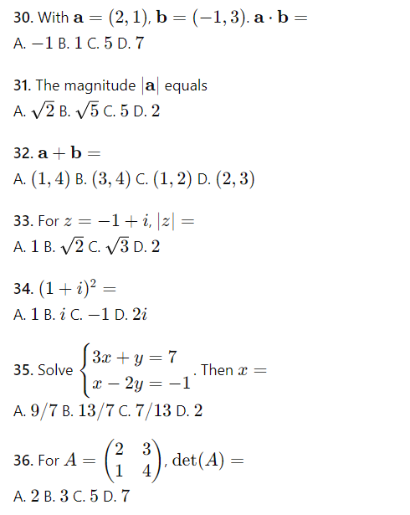
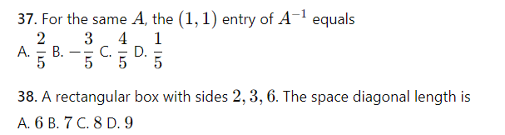
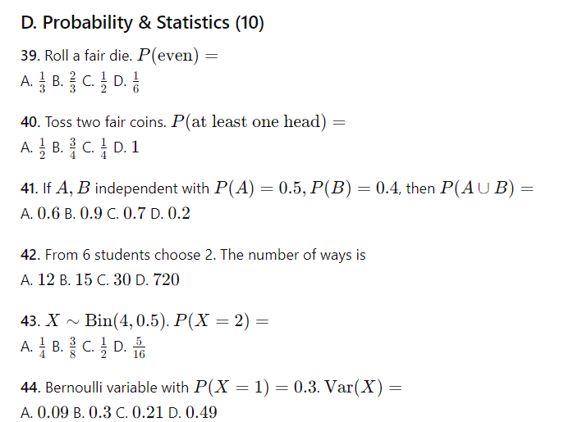
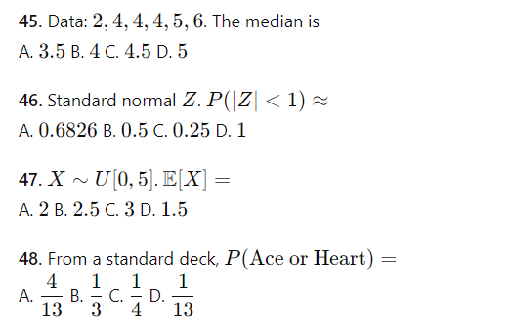

Answer Key
1 C 2 C 3 C 4 B 5 C 6 D 7 B 8 A 9 C 10 A
11 A 12 B 13 C 14 A 15 A 16 A 17 C 18 B 19 C 20 B
21 A 22 B 23 B 24 C 25 A 26 A 27 A 28 B 29 A 30 B
31 B 32 A 33 B 34 D 35 B 36 C 37 C 38 B 39 C 40 B
41 C 42 B 43 B 44 C 45 B 46 A 47 B 48 A

Math Mock 3 (in English) Difficulty level: 85
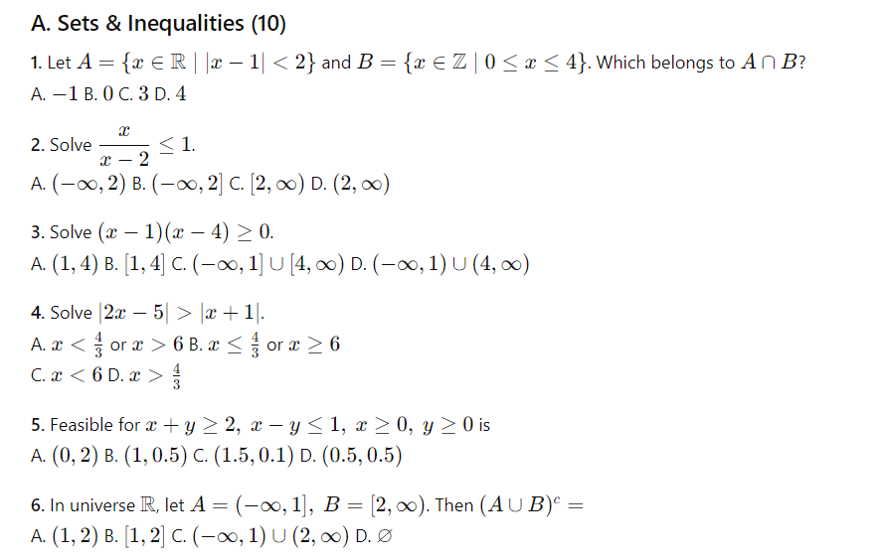
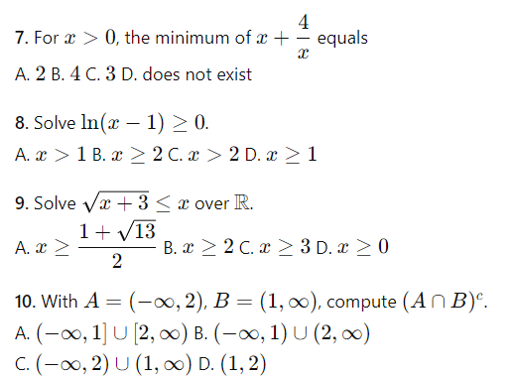

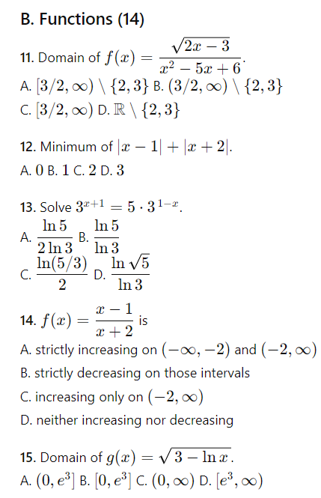
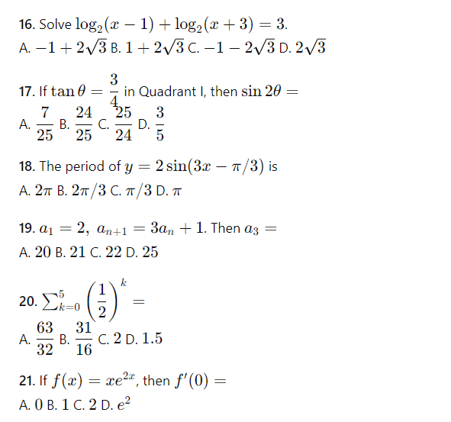
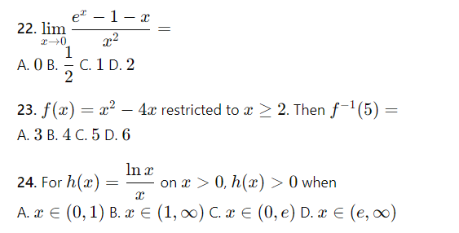
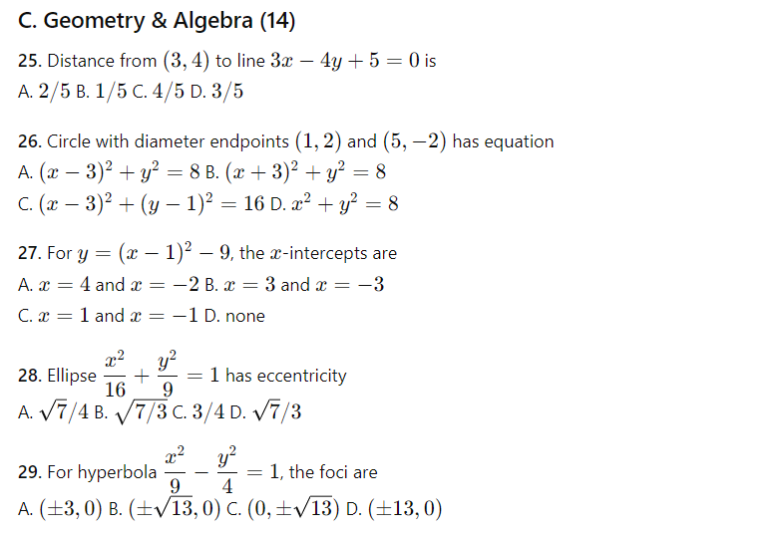
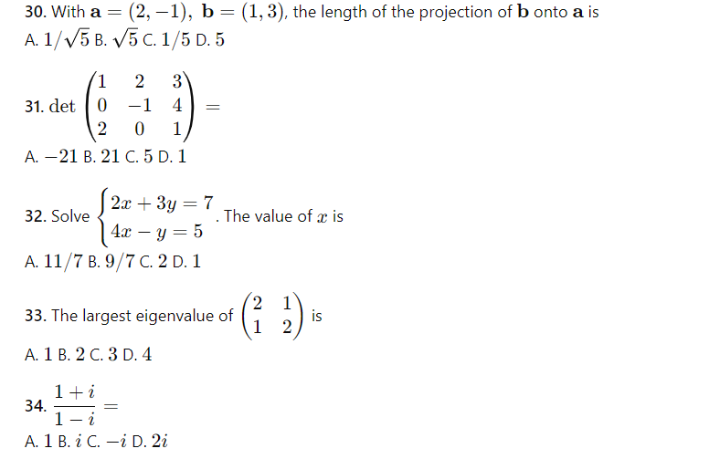
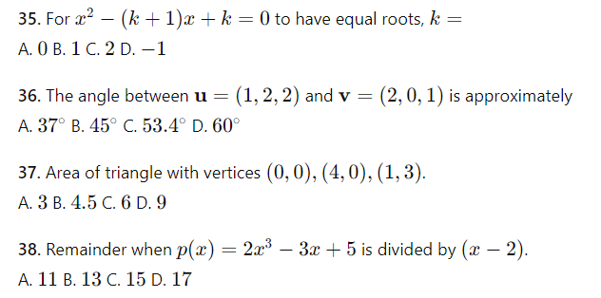
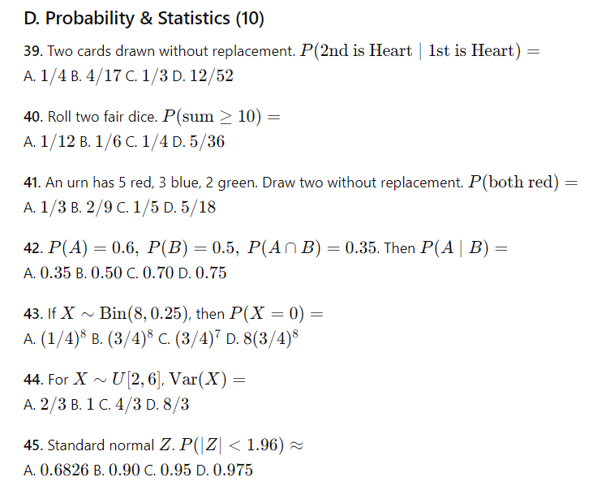

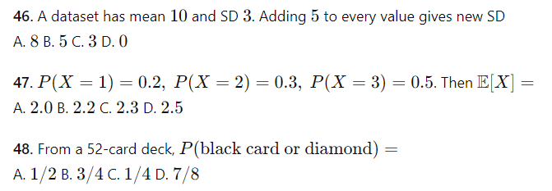

Answer Key
1 B 2 A 3 C 4 A 5 A 6 A 7 B 8 B 9 A 10 A
11 A 12 D 13 A 14 A 15 A 16 A 17 B 18 B 19 C 20 A
21 B 22 B 23 C 24 B 25 A 26 A 27 A 28 A 29 B 30 A
31 B 32 A 33 C 34 B 35 B 36 C 37 C 38 C 39 B 40 B
41 B 42 C 43 B 44 C 45 C 46 C 47 C 48 B

